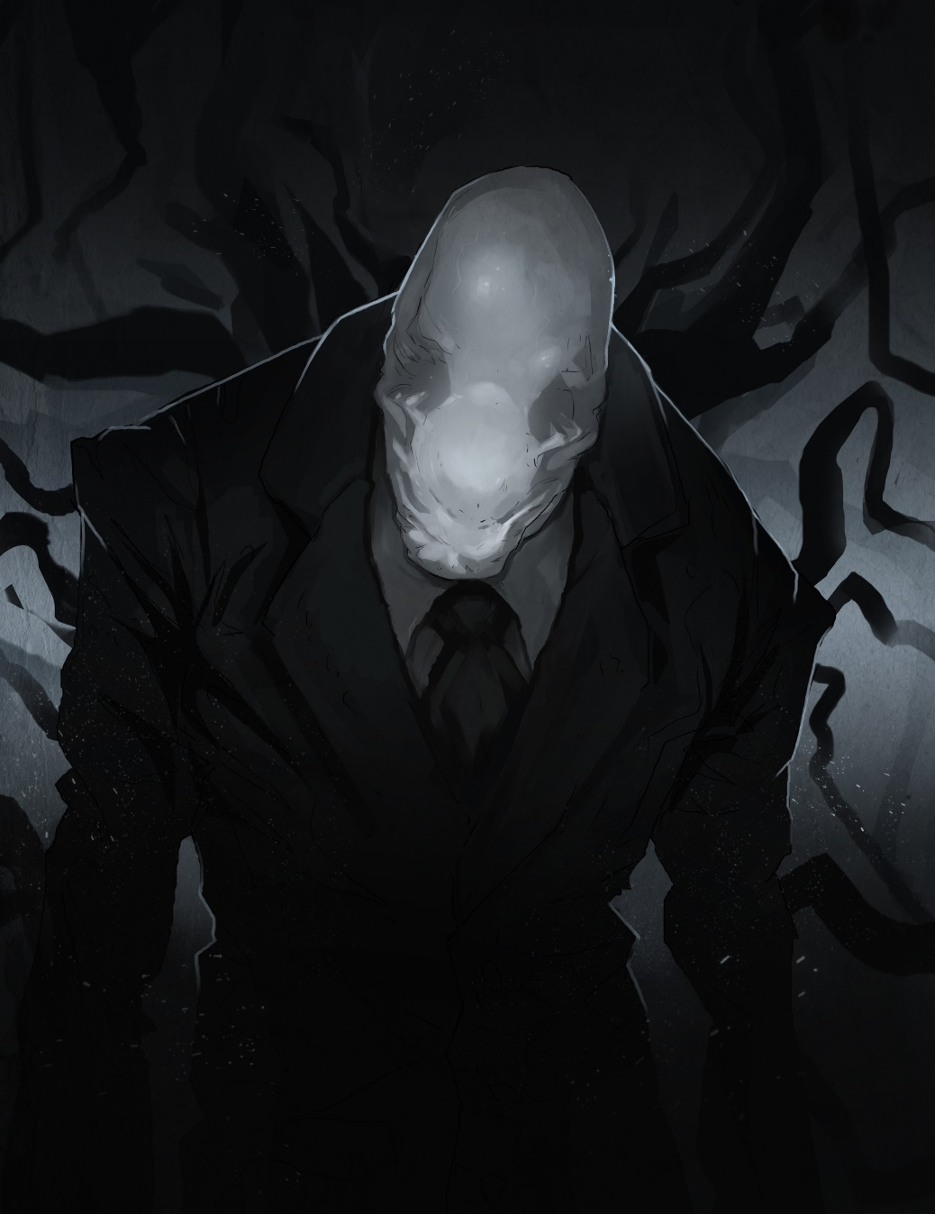

About
This is a project report of my personal project development of research, design, and prototyping of a chosen mobile application. Completed to pass the course cs104 in the 4 weeks of time given.
by Ian Teves

Project

Development

Report
  - CS104

Table of Contents
Introduction 3
Project Strategy 3
Values 3
Ways to track progress 4
UX Research 5
Introduction 5
Key Objectives 5
Hypothetical Scenario 5
Objective and Strategy 6
Who is “Blue Isle Studios Inc.”? 6
Target Audience Needs 6
User Needs 7
Slender: The Arrival Research 8
Competitor Analysis 9
Conclusion 11
Research 12
Survey 12
Interview 13
Interview Results 14
Research Conclusion 17
Analysis 18
Assumptions (Revised) 18
Personas 18
18
Design and Prototype 19



Introduction
This is a project report of my cs104 course to analyse, research, test, prototype and design a mobile application to be improved in the duration of 4 weeks.

Project Strategy
To ensure the success of the project report and its completion in time, I decided to produce a strategy to keep me on task and meeting my deadlines.

Values
These values are ordered in their importance and following
- Frequent delivery of completed projects
- Simplicity of project to meet time crunch deadlines
- Iterative testing of projects
- Regular reflections on how to become more effective

Project Timeline
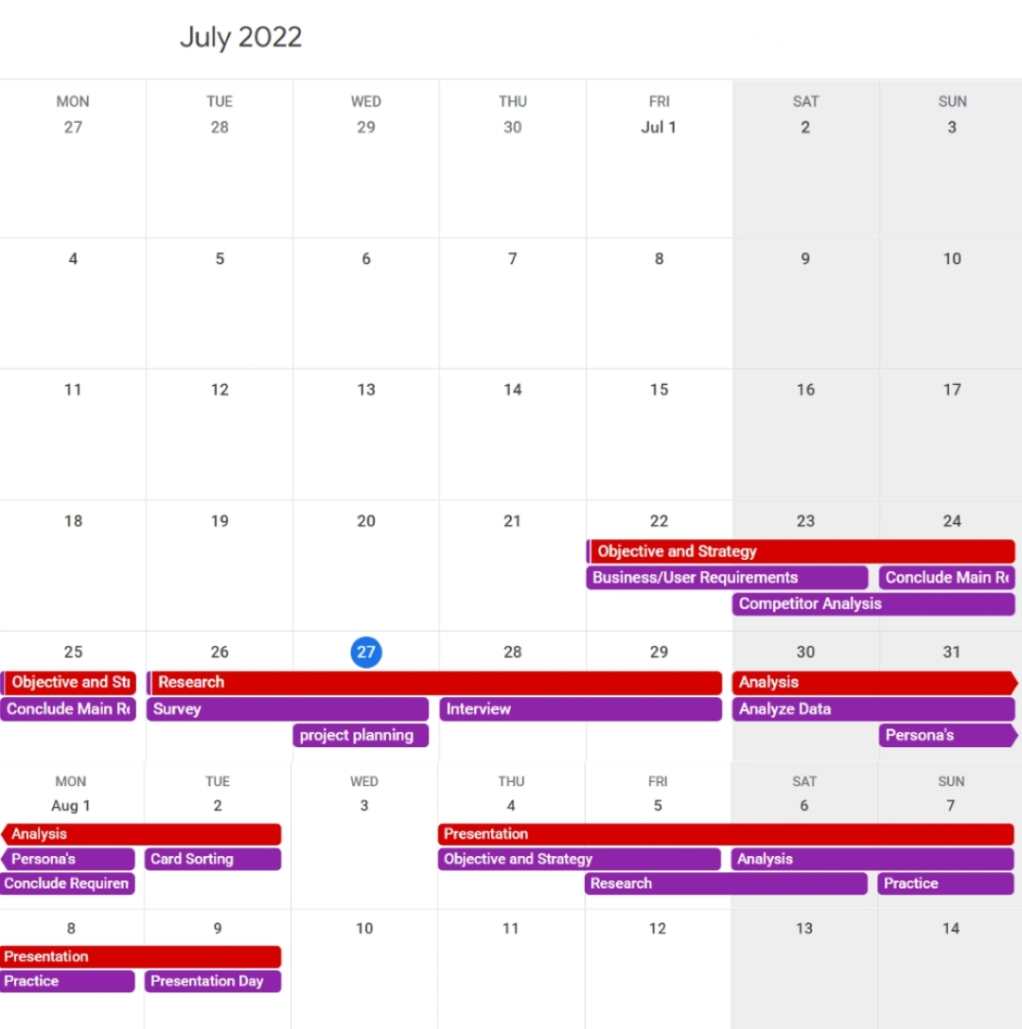

Symbols
Red:
Project

Purple:
Project Tasks

Ways to track progress

- GitHub
  - I’m using GitHub to track tasks to be done, tasks in progress, and completed tasks as the project report is also located inside GitHub. The reasons for this are due to GitHub being able to track commits and pulls to track my activity and progress of the project. GitHub Project Manager makes this much easier, as it enables converting tasks inside the site to track progress and activity on the project.
- Google Calendar

  - Google Calendar is used to plan and track tasks completion. Instead of using a Gantt chart I found using google calendar is enough due to its simplicity and easier to manage and edit tasks and events. While its not a good scheduling tool for a large team of members, for an individual project or a small group of developers, it is a powerful tool to plan projects effectively and efficiently.



UX Research

Introduction

Key Objectives
- Objective
- Strategy
- Research
- Analysis
- Presentation

Hypothetical Scenario
I have been approached by my client “Blue Isle Studios Inc.” to produce research to better understand the pitfalls and strengths of their mobile application “Slender: The Arrival.” This is to help in creating and producing a proposal of a prototype later on to improve ‘users experience’ by updating the UI, models and etc. to meet business needs of increasing profit by increasing downloads by the applications appealing gameplay.

Objective and Strategy

Who is “Blue Isle Studios Inc.”?
Blue Isle Studio Inc is an independent developer and publisher located in the city of Toronto in Canada. They are led by Alex Tintor and Brenden Frank which helps guide and direct the company in creating games that excites their audiences. They produce games available mostly on consoles and pc, but the company was mainly founded by their popular game called “Slender: The Arrival, ” which is a spin off of the popular game “Slender: The Eight Pages.”
After its burst in popularity died down and they now look back at their very foundation, they want to understand their pitfalls and strengths and remaster their first ever game to give back to their studios first clients/fans by providing a remastered version of the game. For the game remaster to be successful in its launch they must research the pitfalls and strengths of “Slender: The Arrival” and compare it with today’s modern competitors. Which can then be used to create a proposal by creating a prototype which is iteratively tested.
Due to the many projects the company is already taking, they are outsourcing to other companies for help. In this case I have been chosen to produce research and prototypes while iteratively testing during the process for the mobile application version of the game.

Business Needs
- Research of pros/cons of “Slender: The Arrival”
- Research is backed by Iterative testing with Target Audience of game
- Increase launch success of remaster of the mobile application by…
  - Research of modern-day competitors
  - Proposing changes to improve Game Quality
  - Proposing changes to improve Game Appeal
  - Proposing changes to improve User Experience
  - Proposing changes to User Interface
Key Need:
Attract target audience of company with features they enjoy leading to a successful remaster of “Slender: The Arrival” and bring profit and attention to the company.

Target Audience Needs
The target audience of this game are the first fans of “Blue Isle Studio Inc.,” the Slender Man community, and horror fans. Assuming this the target audience age range from 14 – 40 due to the age group which was born in slender man era and anyone that is old enough to enjoy horror games.
I assume that the target audience for the games remaster wont defined by anything else due to horror being a universal fear.

I believe to successfully launch “Slender: The Arrival” to the target audience the game must…
- have basic instructions to guide the player to their first goal
- have basic instructions for player controls and how to interact in game
- be consistent within the Slenderman storyline
- build upon the original origin of Slenderman
- have good gameplay that gives a sense of fear and excitement to the player to increase immersion in the atmosphere and story
- have good graphics that immerse the player
  - due to the limitation of mobile devices, maybe stylizing to retro design to decrease problems of graphics limitations
- have good UI to further immerse player into story

User Needs
For the game launch to be successful, the game must be appealing to its users. Game design fundamentals that must be taken into consideration to create a successful game appealing to the users are Objectives, Meaning Play, Design, Interactivity and System. For a game limited as a mobile application, controls and design is limited due to the decreased mobile processing power and touch screen controls.

I assume that for a horror mobile application to be successful, the game must meet the users’ needs which I assume are…
- good game controls / sensitivity
- good goals / objectives (interactivity in the world)
- good instructions to lead the player to the next objective
- good graphics and music to immerse player into the atmosphere
- attractive User Interface to increase immersion and gameplay
- Good Cognitive or Interpretive participation of the of the player by creating immersive events such as note gathering, Slenderman interaction and etc.
- Good Utilitarian Participation by creating a good environment which the user interacts with by decreasing player interactive objects to further increase helplessness in the game – to further extenuate the horror genre
- Good Explicit Interactivity by making…
  - good controls of joysticks. I believe invisible joysticks would be the best to increase further immersion in the game.
  - good main menu and options menu to increase readability and immersion
- Good Meta-Interactivity by following / adding onto the already built fan base of Slender Man by including notes and hints in the game

Slender: The Arrival Research
To fully understand the needs of users and how to appeal to its target audience, I must do some research on the game and find its Strength, Weaknesses, Opportunities, and its Threats.


What is Slender: The Arrival About?
The game is about a person whose car breaks down in the middle of nowhere. There is a path leading down into the forest which the player tasked to traverse to find help. But is met with strange writings and is chased by a tall faceless slender man that aiming to kill the player. The player only carries a flashlight and a recorder and is stuck in the forest until they finally uncover the origins of the slender man.

SWOT Analysis
Strengths
- The graphics is great with great atmospheric filter design to make immerse the player into the game
- Binaural sounds to increase immersion and realism increasing player immersion
- Different Sound Effects and Music when entering different areas
- Cut scenes, art and music is high quality
- Indication of interactivity is indicated by a white highlight making interactivity understandable and easy

Weaknesses
- It’s a mobile application which has less processing power, leading to use of bad graphics which takes the player out of their immersion
- User Interface controls is distracting and not attractive
- High Sensitivity and Reactivity of Controls is nauseating to control
- No objectives given at the start of the game
- Main Menu font is hard to read
- Main Menu is unattractive
- No instructions of goal or controls
- Running is infinite

Opportunities
- Maybe stylize the game more to avoid the limitation of bad graphics due to decreased processing power of mobile applications (retro)
- Redesign of the main menu to increase readability
- Redesign of Player Control
- Introduction of controls and objectives via notes or character voice lines
- Giving the option of invisible control joysticks to immerse players into the atmosphere
- Having a stamina bar or indication through vision blurring or player breathing to increase realism and immersion

Threats
- The highly sensitive controls causing nausea will decrease the audience which the game can be marketed to
- It relies on the user knowledge that they understand how to use a joystick and how to move and look around in a mobile game
- The high graphics demand for good an immersive gameplay is demanding and may not be met by outdated phones decreasing audience market

Competitor Analysis
To Successfully Understand the requirements to achieve a successful launch of the game in the mobile game market, I will be testing modern day horror games in the mobile market to identify the strengths, weaknesses, opportunities, and threats horror games faces in the present market.

Distraint: Pocket Pixel Horror
Strengths
- Stylized Art / Graphics appealing to the horror genre which suits its story and narrative immersing the player in the gameplay
- Good music to immerse player into the story
- Atmospheric Filters are used effectively to create immersion in the story of the game, giving emotions of fear and discomfort to the user
- Good gameplay and controls with a linear narrative to indicate objectives via story
Weaknesses
- Controls are not well suited for mobile
- User Interface is bad due to the use of letters for buttons of menu, inventory, and action as “A, B and C”
- Buttons take over half of the screen taking immersion away from the game
- Game screen is incorrectly proportioned making the game unattractive
Opportunities
- Correctly portion the game screen to increase attractivity of game as well as increase player immersion
- Better control UI
Threats
- Game targets more adult users to understand the story and be immersed as its narrative is adult in theme (man committing suicide due to regret)

Limbo
Strengths
- Stylized Art / Graphics appealing to the horror genre which suits its story and narrative immersing the player in the gameplay
- Good music to immerse player into the story
- Atmospheric Filters are used effectively to create immersion in the story of the game, giving emotions of fear and discomfort to the user
- Good gameplay and controls with a linear narrative to indicate objectives via story
- Invisible Controls / Joystick making the game much more immersive
Weaknesses
- Instructions are not well displayed
- Instructions are not clear enough
- Finding the menu and instructions are difficult as exit / options button is invisible
- Interactable objects are not made clearly
Opportunities
- Highlighting of interactable objects / a button which highlights interactable objects would make the game a lot easier to traverse and enjoyable
- Non invisible options / menu button to make finding instructions easier
- Tutorial based start with instructions to make game more streamlined
Threats
- Game targets older users 14+ to solve the difficult puzzles in the game
- Games story is hard to follow and understand unless analysed deeply which leads to a confusing story / narrative. Game only targets everyone who likes its gameplay and puzzles rather than its narrative

Endless Nightmare
Strengths
- Cutscenes are high in quality making the game fun to explore
- Graphics is high in quality making looking at decorations and the map fun to explore
Weaknesses
- Map is not well decorated (copy pasted pictures of Jesus and Mary and the last supper is everywhere to fill up the map)
- game is Ad ridden going by pay to win making playing annoying
- High quality graphics unsuited for mobile devices leading to unsatisfying and non-immersive art and models in game
- UI is ugly filling up the screen
- Enemy doesn’t strike fear to player due to it never being present
- Narrative and storyline are confusing that the player has to rely on the objective instructions text to continue the story
- Due to the lower graphics performance of mobile devices, they created unrealistic police tape barriers which is completely immersive to the player.
Opportunities
- Having a very high in quality game focusing on simple puzzles to keep the high quality rather than lose it to quantity of features
- Remove the ads and make it a paid game to attract players that will enjoy the game
- UI improvements to fit theme of game more
Threats
- Due to the large amount of fp-rpg (first-person role-playing game) in the mobile app store, standing out as a horror game is difficult. Due to the lack of quality of the game, it cannot attract anyone or any communities as the story attracts a mature audience while the ads and extra features they add for micro transactions take away from it

Conclusion
For the game to succeed in its launch, I believe that the threats and needs that must be considered moving forward are…
- Attract target audience of company with features users enjoy leading to a successful remaster of the game and bring profit and attention to the company
- Attract and suit the target audience of...
  - users ranging from 14 - 40 years in age
  - Slenderman community
  - horror enthusiasts
- To successfully attract these audiences the remastered launch must...
  - have story driven objective where user is driven to find objectives through narrative implications
  - have basic instructions to guide player (either by story / narrative / visual design)
  - have basic instructions of player control and world / object control to include users that are not well versed in mobile controls
  - build upon the origin of Slenderman to attract the Slenderman community and not just be a repeat of the first game
  - have a retro / stylized art style to avoid graphics limitation on mobile device
  - have good cognitive and utilitarian participation by creating a good environment with limited character controls to face events such as note gathering and running away from slender man to increase fear / emotional immersion in the game
  - Good Explicit Interactivity by making…
    - good controls of joysticks. I believe invisible joysticks would be the best to increase further immersion in the game.
    - good main menu and options menu to increase readability and immersion
  - Good Meta-Interactivity by following / adding onto the already built fan base of Slender Man by including notes and hints in the game
- Lessons learnt by gameplay tests and competitor analysis are…
  - redesigning main menu and options menu are important to introduce the game well to the user and immerse them into the story
  - redesign of player controls / UI such as invisible controls and decreased sensitivity
  - adding a rule of stamina and adding visual indication through stamina bar or screen blurring
  - adding instructions and objectives to help first time players out as it relies on users already knowing how to play in mobile as well as learn to follow objectives
  - realism doesn’t equal into a better horror experience, but the atmosphere created by well-matched themes of music, art, and game design

These needs must be met to achieve the business need of attracting target audience of company with features they enjoy leading to a successful remaster of “Slender: The Arrival” and bring profit and attention to the company

Research
To ensure that my assumptions on the reasons I have given of ‘threats and needs’ to be met to ensure the success of the games remastered launch is reasonable, I have created a survey and conducted interviews to validate my reasoning.

Survey
This survey is to understand the requirements needed to be met to increase the chances of success of the remaster of “Slender: The Arrival” launch into the mobile market. (This is the summary of all surveyed user’s answers.

What is your age group?
- 14 – 20 (2)
- 20 – 30 (8)
- 30 – 40 (0)
- 40+ (3)

What is your technological level?
- low (4)
- average (5)
- high (6)

What is your likelihood on playing a horror game and why?
- low (6)
- average (4)
- high (5)
- Users are either scared or they just don’t have the time or interest to play a horror game.
- Some users also doubt their skills to play any type of games and comments that its past their time to play games due to their age.
- Users that would play a horror game are thrill seeking fans with a love for the horror genre.

Should a horror game imply the next task / objective through a objective menu or through narrative implications? (Should it outright tell the user what to do next or imply it through the story)
- yes (5)
- no (10)
- it should because they are not good at playing games and
- it shouldn’t to prevent player un-¿immersion

Should a mobile horror game have controls instructions (how to move character and interact) or assume that the player already knows the controls?
- yes (15)
- no (0)
- yes as not everyone is familiar on how to play mobile games

What do you expect to see on a mobile horror game?
- a scary character as well as scary scenes / encounters
- horror themed art and music to scare / make the player uneasy
- footstep sounds
What do you believe is important for a horror game to succeed in the mobile market?
- Jump scares.
- Good Atmosphere created by good choices of game design / art and music through ambience and footsteps and etc.
- Dark atmosphere.
- Scary characters.
- A fanbase built behind the game (compared to poppy playtime and five nights at Freddy’s)
- Easy and simple controls.

What problems do you think you will have when playing a mobile horror game?
- controlling the character
- being engaged
- solving the puzzles
- understanding what to do / the next step
- seeing and navigating the world

Interview
This Interview is to understand and assure the assumptions I made about the overall User Interface and User Experience of the game by giving instructions to the user that they attempt to achieve in the 10-minute time limit of the interview.

Instructions
- download “Slender: The Arrival” on your phone
- Give Survey to Interviewee
- Give the phone to Interviewee
- Ask Interviewee to…
  - open game
  - watch the whole opening scene
  - read the menus on the title page
- Ask the interviewee to comment on the…
  - how is the opening scene effective / ineffective in player immersion in the game?
  - title page menu and how it is effective / ineffective in player immersion in the game
- Ask Interviewee to…
  - watch game opening scene
  - Sprint and look around in the game
  - go to menu and change look sensitivity if the controls are too high or low in sensitivity
- Ask the interviewee to comment on the…
  - rate the effectivity of the opening scene of the game and why is it effective / ineffective in creating player immersion in the game?
  - difficulty in finding out controls from 1-10
  - difficulty in controlling character from 1-10
  - difficulty in finding menu from 1-10
  - why were they difficult and what do you suggest decreasing difficulty?
- Ask Interviewee to…
  - Follow the path and find the house
  - find the swing and slide and go beside them around the house
  - go inside the house and find the 1st note beside the stairs
  - find the flashlight inside the house
  - find the second note
  - find the keys to open the locked bedroom on the 2nd floor of the house and find the third note
  - go outside to the back of the house and exit to the back yard to go to the second house by following the path
  - find the ghost
  - find the note
- Ask the interviewee to comment on the…
  - difficulty of finding next objectives from 1-10
  - difficulty in navigating the map from 1-10
  - how do you rate the art and design of the game from 1-10 and why?
  - how do you rate from 1-10 the story objective system that the game has?
  - how do you rate the controls of the game from 1-10 and why is it effective / ineffective?
  - Would you suggest adding extra rules of character stamina in the game or no?
  - Would you suggest having more instructions on character control in the game or no and if so why?
  - Would you suggest having an invisible control joystick for a much more immersive gameplay and if so why?
  - Would you suggest adding an Objective Menu to understand your next task and if so why?
  - What do you believe “Slender: The Arrival” is lacking to be successful in today’s modern mobile market?

Interview Results
The interview resulted in finding out different unknown game mechanics as well as difficulties overlooked of playing the game. (This is the summary of all interviewee’s comments on the user experience and user interface of the game)

Mobile application opening scene comments…
It was effective in creating player immersion due…
- to horror themed sound / music and art which brought uneasiness feelings.
It was ineffective in creating player immersion due…
- to it compromising of the companies and tools that is used / participated to create the game. The user expected a slender man opening scene.
- Reminds them of old horror movies and found it funny and nostalgic instead of scary and uneasy.
- players thought it wasn’t entirely necessary, though they liked being able to skip it

Title Menu comments…
It is effective in creating player immersion due…
- to it using horror themed art and music.
- to creepy font / handwriting
It is ineffective in creating player immersions due...
- too hard to read font
- bad lighting of the menu making it hard to read the words

Game opening scene comments…
Opening scene player immersion effectivity rating (8.7 / 10)
It is effective in creating player immersion due to…
- good music and lighting to match with the art as well as narrative driving the uneasiness feeling of the scene
- good setup for story/incentive to play
- dark atmosphere created by music and art
- spooky music
It is ineffective in creating player immersion due to…
- small writing making it hard to read

Character control comments…
difficulty controls rating (2.3 / 10)
It’s difficult to control due to…
- high sensitivity (even with the lowest setting)
- unknown and unfamiliar with playing games on the phone
- not used to playing mobile games
It’s not difficult due to…
- being used to playing mobile games
- familiar with mobile game controls
- familiar with sensitivity

Objective and Map navigation comments…
difficulty in finding menu rating (0 / 10)
it’s difficult to find the menu due…
- to the screen being surrounded by larger UI
- assumed it would be at the centre of the screen
It’s not difficult due…
- to the assumption that menu / setting button is always at the top or left side of the screen

Difficulty in finding the next objective comments…
difficulty in finding out next objective rating (4.9 / 10)
it’s difficult to find the next objective because…
- the story notes can’t be read due to accidental touches exiting reading mode and never being able to read that clue ever again
- the letters are too small making it hard to read
it’s not difficult because…
- objective is listed in the objective menu
- just normal difficulty in horror puzzle games

Difficulty in navigating the map comments…
difficulty in map navigation rating (1.6 / 10)
it’s difficult to navigate the map because…
- when door is shut when you’re in front of it. It can lead you to bug through and fling you into the roof.
- doors and windows automatically interact without being interacted with
it’s not difficult because…
- they are familiar with mobile controls and how games work

Art and Design comment…
art and design rating (7.7 / 10)
the art and design of the game was good because…
- its spooky
- it matches in themes of dark and horror to create a sense of uneasiness to the player
- most users thought the graphics was good as it is
the art and design are not good because…
- the high demand of the game for loading high graphics made the game laggy resulting in having to decrease graphics quality
- graphics not matching in resolution in some parts of the game due to lower quality

Objective system comments…
objective system rating (6.9 / 10)
the objecting system of story / narrative implications was good because…
- it led them from one story to the next and doesn’t break player immersion
- it told a story and made the player have to understand it to understand the next objective
no, it wasn’t good because…
- note reading was difficult as it would lead to accidental touches which would put it away when the player has not finished reading it
- reading the notes were difficult due to small letters
- could not find out next objective as they couldn’t bring up the note they just red to read again

Game control comments…
game controls rating (8.4 / 10)
game controls were good because…
- it was easy and intuitive
- game UI was where they were expected to be
- highlighted objects that were interactive made the game easy to navigate
game controls were not good because…
- accidental touches occurred because the whole screen was a button to interact and close reading mode
- UI filled up the whole screen and was not pretty
- UI was okay as it was intuitive but could look better

Extra additions comments…
Would they suggest adding extra rules of character stamina in the game or no?
- Yes as it would add extra difficulty in the game
- No as they felt it was good enough as it is (most interviewees felt this way)
- No as it would make running across the map annoying and boring

Would they suggest having more instructions on character control in the game or no?
- yes as it’s always good to explain all controls of a game
- no, as they felt there was enough instructions in the game

Would they suggest having an invisible control joystick for a much more immersive gameplay and if so why?
- yes to adding transparent controls to increase immersion to gameplay
- no to adding transparent controls as it would make it harder to play the game
- no, as they believe its fine as it is

Would they suggest adding an Objective Menu to understand your next task and if so why?
- yes to adding an objective menu and instructions to make it easier to go through the game
- no to adding an objective menu and instructions as they believe that its common knowledge
- objective menu has already been added into the game at the setting when pausing the game

What do they believe “Slender: The Arrival” is lacking to be successful in today’s modern mobile market?
- transparent controls / buttons to decrease cluttering of screen
- larger writing
- nothing as they feel that its good as it is
- adding slender man at the start of the game to make the player more fearful of their surroundings (never saw Slenderman in the 10 min play time)
- fix door collision bug
- make the go back button when viewing papers as the main button to exit reading view as it leads to accidental touches making finding out next objective through story difficult
- make objective menu easier to find out to the player
- Adding a reading mode where letters are easier to read
- Adding an inventory to look back at previous notes picked up
- Serious optimizations to run better

Research Conclusion
Doing a survey as well as Interviews helped me in understanding the goals, needs, behaviours and exceptions the user have of the game. They are…
- Having an option for transparent controls for those looking for more immersion in the game
- Keeping UI position the same but creating an interact button as well as inventory button to see past notes
- Having an objective menu to make the next task easy to understand
- Having more instructions over character control, interaction, objective menu and etc. to make sure player understands what they have to do.

Analysis
Using the research gathered, we can put together a collection of typical personas which would play the game and use the interviews and surveys come up with suggestions and improve the game further. These suggestions have been compiled below:
- Users want the game to run smoother, see some bug fixes too
- Users want to be able to customise the controls, e.g. change the size of joystick, make them transparent
- Users would like to make finding the objective a bit easier
- Users want the starting menus to be brighter, and see a font which is easier to read

Revised User Requirements
- Users feel that the game sensitivity needs work
- Goals and objectives very vague, the objectives screen could at least be easier to find
- Users say the appearance of the game needs a fair amount of work, though the sound is fantastic
- The interface is okay, though users want some customisability to aid their immersion
- The note gathering across a big map users found frustrating, though it pushed them perfectly into feeling helpless
- Users believe the controls don’t obstruct much of the game, though the option to turn them off would help the feeling of helplessness
- Users believe the main menu is poor and is in dire need of an update

Personas
